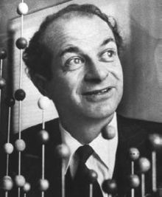
Linus Carl Pauling (February 28, 1901 – August 19, 1994) was an American chemist, biochemist, peace activist, author, and educator. He was one of the most influential chemists in history and ranks among the most important scientists of the 20th century. Pauling was one of the founders of the fields of quantum chemistry and molecular biology.
For his scientific work, Pauling was awarded the Nobel Prize in Chemistry in 1954. In 1962, for his peace activism, he was awarded the Nobel Peace Prize. This makes him the only person to be awarded two unshared Nobel Prizes. He is one of only four individuals to have won more than one Nobel Prize (the others being Marie Curie, John Bardeen, and Frederick Sanger). Pauling is one of only two people to be awarded Nobel Prizes in different fields (Chemistry and Peace), the other being Marie Curie (Chemistry and Physics).

